BLACKBOARD
Instructor Guide for Enabling Courseload Textbook Access in Blackboard
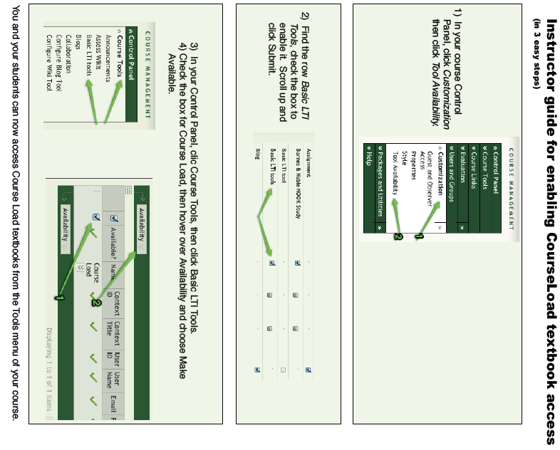
Accessing Courseload in Blackboard
Login and access Blackboard as usual. After selecting the participating course, select Tools from the upper menu at the left, then click on “Basic LTI Tools”, then click the Courseload button.

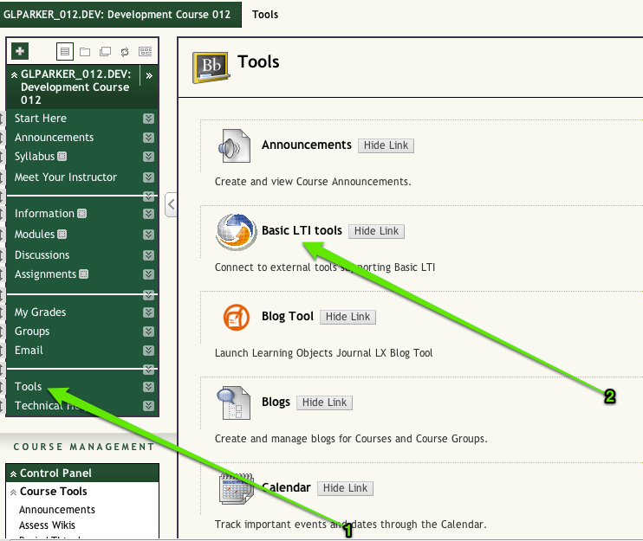

Supported Browsers
Courseload can be used on any device with an Internet connection using Internet Explorer 9 or later, Firefox 4 or later, Safari 4 or later, or Google Chrome 11 or later. (Courseload may work with other browsers, but they have not been thoroughly tested.) Also, be sure to enable cookies and allow pop-ups.
Windows | Mac OS X | Unix/Linux
Internet Explorer (9.0+)
Firefox (4+) | Firefox (4+) | Firefox (4+)
Safari (4+) | Safari (4+)
Google Chrome | Google Chrome
Note: Internet Explorer 7 & 8 users can access Courseload by installing a plugin located here: http://www.google.com/chromeframe/eula.html?user=true
Courseload Help
Once in the Courseload reader, there is a help link located in the upper right-hand corner (blue, next to logged in name) which will open in a new window:
http://courseload.mindtouch.us/?institution=usf
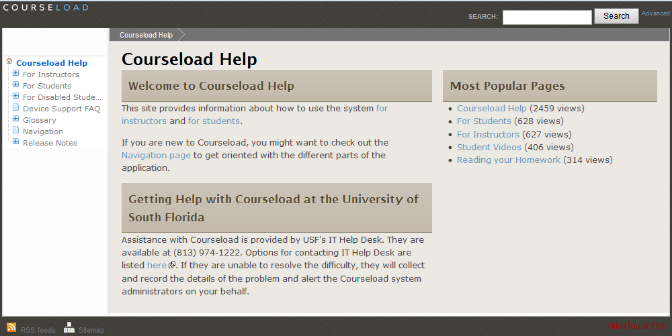

Courseload’s instructor specific help is located at:
http://www.courseload.com/instructortraining?institution=usf

Additional Information and Contacts

Textbook Affordability Project (TAP)
Please see our Textbook Affordability Web site for general pilot information and links to detailed instructions and FAQs. We are continually updating these pages to provide the latest information you need.

USF Textbook Affordability Web site: http://tap.usf.edu/
Faculty FAQs: http://tap.usf.edu/faculty/internet2-educause-faculty-faq/
Student FAQs: http://tap.usf.edu/students/internet2educause-student-faq/

Courseload Information
Couseload help: http://courseload.mindtouch.us/?institution=usf
Courseload instructor training: http://www.courseload.com/instructortraining?institution=usf
Courseload documentation PDF: http://help.courseload.com/help/documentation.pdf
(old resource, some functions may have changed.)

Contacts
For faculty assistance, please contact Laura or Alex:

Laura Pascual
lcpascua@mail.usf.edu
(813) 974-2483
Alexander Neff
neffa@mail.usf.edu

Please direct all student help requests to:
USF IT Help Desk
http://www.it.usf.edu/help
(813) 974-1222 or Toll Free (866) 974-1222

Project Administrator:
Monica Metz-Wiseman
Coordinator of Electronic Collections
USF Library System
monica@usf.edu,
(813) 974-9854

