CANVAS

Accessing Courseload in Canvas

Access your course in Canvas and select Modules from the menu at left.

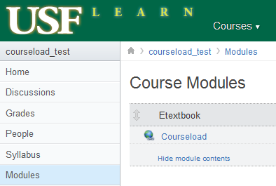
1. From Modules, Select Etextbook Module.
2. Click on Courseload Tool.

1

2

3. Click on “Load Courseload in a New Window” button.

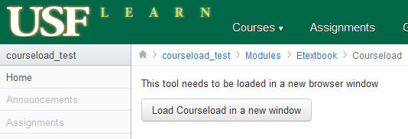

3

Supported Browsers
Courseload can be used on any device with an Internet connection using Internet Explorer 9 or later, Firefox 4 or later, Safari 4 or later, or Google Chrome 11 or later. (Courseload may work with other browsers, but they have not been thoroughly tested.) Also, be sure to enable cookies and allow pop-ups.
Windows | Mac OS X | Unix/Linux
Internet Explorer (9.0+)
Firefox (4+) | Firefox (4+) | Firefox (4+)
Safari (4+) | Safari (4+)
Google Chrome | Google Chrome
Note: Internet Explorer 7 & 8 users can access Courseload by installing a plugin located here: http://www.google.com/chromeframe/eula.html?user=true
Courseload Help
Once in the Courseload reader, there is a help link located in the upper right-hand corner (blue, next to logged in name) which will open in a new window:
http://courseload.mindtouch.us/?institution=usf
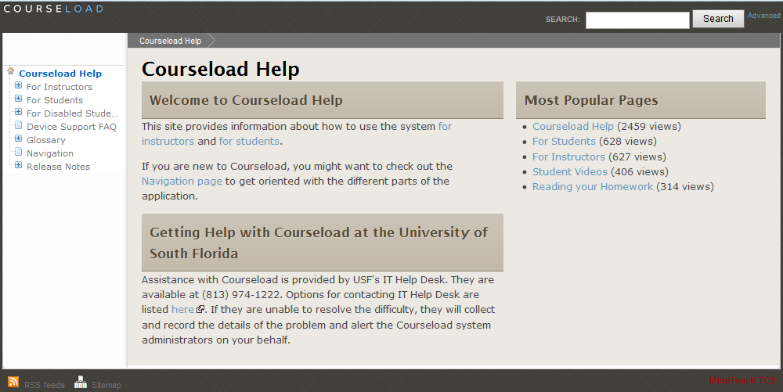

Courseload’s instructor specific help is located at:
http://www.courseload.com/instructortraining?institution=usf

Additional Information and Contacts

Textbook Affordability Project (TAP)
Please see our Textbook Affordability Web site for general pilot information and links to detailed instructions and FAQs. We are continually updating these pages to provide the latest information you need.

USF Textbook Affordability Web site: http://tap.usf.edu/
Student FAQs: http://tap.usf.edu/students/internet2educause-student-faq/

Courseload Information
Couseload help: http://courseload.mindtouch.us/?institution=usf

Contacts
Please direct all student help requests to:
USF IT Help Desk
http://www.it.usf.edu/help
(813) 974-1222 or Toll Free (866) 974-1222

