**CANVAS**

**Instructor Guide to Placing the Courseload External Tool in a Canvas Course Module**

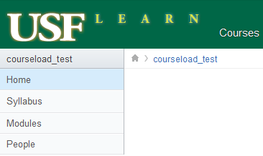

1. Click Modules

**1**



2. Click Create a Module

**1**

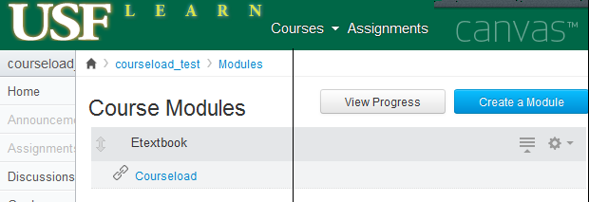

**2**

3. Type Module Name “Etextbook” in Box.

4. Click Add Module

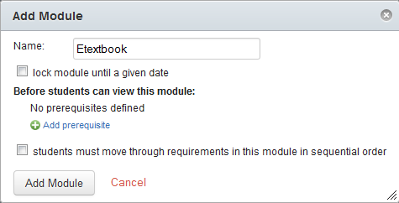

**3**



**4**



**Add Courseload Tool to Canvas Course Module**

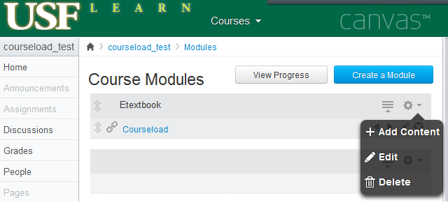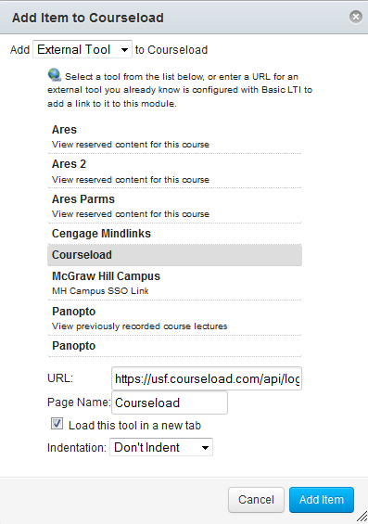

**5**

**4**





2. Select External Tool from Drop Box.

3. Select Courseload

4. Check “Load this tool in a new tab.”

5. Click Add Item.



1. From Modules, Click to Add Content.

.

**1**



**Etextbook**

Etextbook

**2**

**3**

**Accessing Courseload in Canvas**

Access your course in Canvas and select Modules from the menu at left.

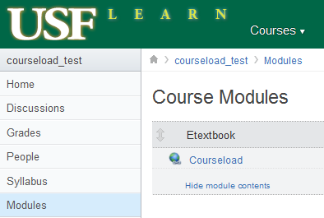

1. From Modules, Select Etextbook Module.

2. Click on Courseload Tool.

**1**

**2**

3. Click on “Load Courseload in a New Window” button.

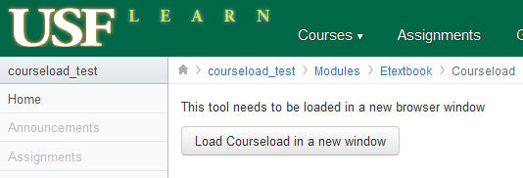

**3**

**Supported Browsers**

Courseload can be used on any device with an Internet connection using Internet Explorer 9 or later, Firefox 4 or later, Safari 4 or later, or Google Chrome 11 or later. (Courseload may work with other browsers, but they have not been thoroughly tested.) Also, be sure to enable cookies and allow pop-ups.

|  |  |  |
| --- | --- | --- |
| Windows | **Mac OS X** | **Unix/Linux** |
| Internet Explorer (9.0+) |  |  |
| Firefox (4+) | Firefox (4+) | Firefox (4+) |
| Safari (4+) | Safari (4+) |  |
| Google Chrome | Google Chrome |  |

Note: Internet Explorer 7 & 8 users can access Courseload by installing a plugin located here: <http://www.google.com/chromeframe/eula.html?user=true>

**Courseload Help**

Once in the Courseload reader, there is a help link located in the upper right-hand corner (blue, next to logged in name) which will open in a new window:

<http://courseload.mindtouch.us/?institution=usf>

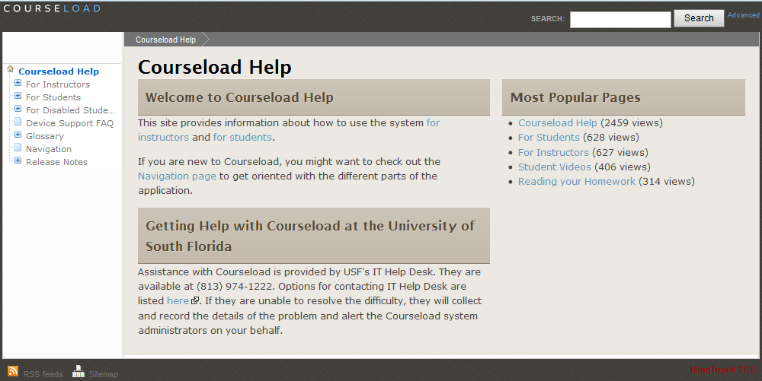

Courseload’s instructor specific help is located at:

<http://www.courseload.com/instructortraining?institution=usf>

**Additional Information and Contacts**

**Textbook Affordability Project (TAP)**

Please see our Textbook Affordability Web site for general pilot information and links to detailed instructions and FAQs. We are continually updating these pages to provide the latest information you need.

USF Textbook Affordability Web site:  <http://tap.usf.edu/>

Faculty FAQs: <http://tap.usf.edu/faculty/internet2-educause-faculty-faq/>

Student FAQs: <http://tap.usf.edu/students/internet2educause-student-faq/>

**Courseload Information**

Couseload help: <http://courseload.mindtouch.us/?institution=usf>

Courseload instructor training: <http://www.courseload.com/instructortraining?institution=usf>

Courseload documentation PDF: <http://help.courseload.com/help/documentation.pdf>

(old resource, some functions may have changed.)

**Contacts**

For faculty assistance, please contact Laura or Alex:

Laura Pascual

[lcpascua@mail.usf.edu](mailto:lcpascua@mail.usf.edu)

(813) 974-2483

Alexander Neff

[neffa@mail.usf.edu](mailto:neffa@mail.usf.edu)

Please direct all student help requests to:

USF IT Help Desk

<http://www.it.usf.edu/help>

(813) 974-1222 or Toll Free (866) 974-1222

Project Administrator:

Monica Metz-Wiseman

Coordinator of Electronic Collections

USF Library System

[monica@usf.edu](mailto:monica@usf.edu),

(813) 974-9854